Welcome to FIM!

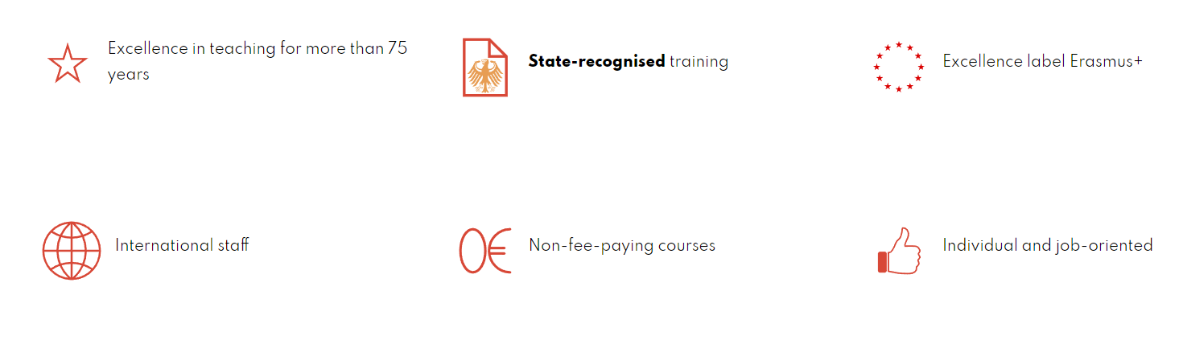

- FIM
  - FIM courses
Interested in languages and culture? Current affairs? Economics or technology?
Then the Munich’s municipal foreign languages Institute, FIM, is for you. We offer two schools under one roof, that meet the demands of the market for those who want to qualify for professions that use foreign languages:
- The Berufsfachschule or BFS, a Vocational training school leading to State-qualified foreign-language correspondent.
- The Fachakedemie or FAK, an academy specialising in languages and international communication, leading to State-qualified translator and interpreter.

These courses can be taken in three languages: English, French and Spanish. The language of instruction is German.
In order to optimise professional skills, these qualifications are concentrated on two specialities: Economics and Technology.

For your Erasmus + stay at FIM, you will attend FAK courses.

By combining languages with a specialist field, the FAK opens the door to a wide range of professional prospects, in which the skills you acquire will be of the greatest use:
- Written and oral communication in several languages
- Professional translation of texts in a wide range of fields, using all available IT tools
- Interpreting in a variety of contexts
- Intercultural approach on an international stage
- ...

  - Location and atmosphere
FIM is located in the heart of Munich, in the university district known as Maxvorstadt. It is also known as the Univiertel. It's a perfect place for students, right in the heart of the museum district, with green spaces, bars, restaurants and trendy designer boutiques. The area is also very well served by public transport and is close to most of the city's must-see attractions.
As well as an immersive experience in a city with many assets, students who take advantage of an exchange at our institute have a lot to gain. For over 75 years, FIM has been a human-scale structure offering highly personalised support and encouraging authentic, diversified and professional learning, delivered by an international teaching staff. The students who stay here particularly appreciate the family atmosphere of our school and its pragmatic approach. All this contributes to the enormous progress in German made by our Erasmus students.
- Preparing for your stay at FIM
  - Application and nomination
As a student at one of our partner universities, you must first apply to your institution to study at FIM. Your institution will then officially nominate you to us under the Erasmus + programme. The deadlines for nominations are:
- For the first semester: 30 June
- For the second semester: 30 November
Once we have received your nomination, we will contact you to provide you with all the information you need to complete your application.

  - Choice of courses
Erasmus students must complete a Learning Agreement with the courses they will be taking at our institution. The form for the Learning Agreement is normally provided by your institution. The FIM academic coordinator will provide you with a list of the courses on offer, including the number of ECTS per course. You can also download the list on our website. This list serves as a basis for completing and sending us your study contract, which you will have received from your university. The list may be subject to changes (number of hours, course names, etc.). The study contract may need to be adjusted when you arrive. You can choose courses in all three years (FAK1, 2 and 3) and in all three languages (F, E, S).
The Learning Agreement must be approved and signed by the academic coordinators of both institutions. If the study contract has been amended, it is important to notify the coordinators so that they have the latest version. Only the courses mentioned in the study contract may be included in your final Transcript of Records document.
- Your stay at FIM
  - Administrative procedures
    - Visa and residence permit
Students from an EU or European Economic Area country do not need a visa or residence permit, just a valid identity document.
    - Declaration of domicile
Students must register their address with the Kreisverwaltungsreferat, the domiciliation office, within two weeks of their arrival. If you change your address during your stay, you must also notify the Kreisverwaltungsreferat. You must also terminate your registration at the end of your stay, either in person or in writing.
To check in, you will need:
- the completed form
- a valid form of identification
- written confirmation from the owner of your accommodation (Wohnungsgeberbestätigung)
The address of the registration office in Munich:
Kreisverwaltungsreferat (KVR)
Ground floor - Ruppertstraße 19
80337 Munich
You can download the form here:
https://www.muenchen.de/rathaus/home_en/Department-of-Public-Order/Registration-Deregistration.html
It is also advisable to make an appointment online to avoid long waiting times.

    - Health insurance
Students must obtain the European Health Insurance Card. This is a free card that allows you to benefit from any public healthcare you may need during a temporary stay in one of the 27 EU Member States, Iceland, Liechtenstein, Norway or Switzerland, under the same conditions and at the same rate (free in some countries) as people insured in that country. The cards are issued by the health insurance services in your country. You can find more information here: https://ec.europa.eu/social/main.jsp?catId=559&langId=fr
    - Accommodation
Finding accommodation in Munich is not easy. FIM has a partnership with the Stundentenwohnheim, which can offer the following options:
- Single room with private bathroom and kitchenette, including breakfast and dinner from Monday to Friday, €800
- Double room with bathroom and kitchenette, including breakfast and dinner from Monday to Friday, €550
Rooms are subject to availability. Prices are indicative only. To make a request, please contact the FIM academic coordinator as soon as possible.
Alternatively, here is a series of useful links for finding accommodation:
- http://www.studentenwerk-muenchen.de/en/accommodation/housing-referral-service/
- http://www.studentenwerk-muenchen.de/en/accommodation/other-housing-options/privately-run-halls-of-residence/
- https://www.uniplaces.com/
- https://www.facebook.com/groups/239343132772206/?fref=ts
- http://www.wg-gesucht.de/
- http://muenchen.studenten-wohnung.de/
- http://www.studenten-wg.de/wohnungsmarkt.html
- https://housinganywhere.com/s/Munich--Germany

    - Transports
Unfortunately, Fachakademie students do not benefit from the Semester Ticket. However, a monthly ticket entitles you to the Ausbildungstarif II discount. You can buy this online (https://www.mvg.de/kundenportal/kundenkarte/bestellen.html) or at the MVG customer centres (Hauptbahnhof, Marienplatz, Ostbahnhof). You are also entitled to the 365-Euro-ticket student annual season ticket (https://www.mvg.de/kundenportal/ausbildungstarif-abo/bestellen365.html#step:AboConfig; or at the customer centres mentioned).
A new season ticket has recently been introduced which can be cancelled every month: the Deutschland-Ticket. The Deutschland-Ticket (D-Ticket for short) lets you travel easily by all means of local public transport from for just 49 euros per month.
- Contact
If you have any questions, please do not hesitate to contact our Erasmus+ team:
fim@muenchen.de

